**SPRINT4**

**MOBILE APP MESSAGE TO USER**

|  |  |
| --- | --- |
| Date | 12 November 2022 |
| Team id | PNT2022TMID50683 |
| Project name | Real Time River Water Quality Monitoring And Control System |
| Maximum marks | 5 marks |

**Connecting the MIT APP INVENTOR with the mobile app and it will display the temperature and ph value of water and also motor on and motor off in the phone of user:**

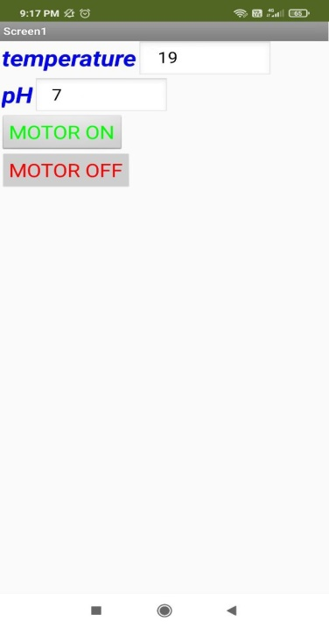

**As the ph value of water is 7, the water is good for drinking.**